Even Semester (2022)



|  |  |  |  |  |  |  |
| --- | --- | --- | --- | --- | --- | --- |
|  |  | |  |  |  |  |
| **Student Information**: | **Surname**  1. Yenata | |  |  | **Given Names**  Ryo | **Student ID Number**  **2201796705** |
|  |  |  |  |  |  |  |
| **Course Code** | **: COMP6510** |  |  |  | **Course Name** | **: Programing language** |
| **Class** | **: L2AC** |  |  |  | **Name of Lecturer(s)** | : 1. Minaldi Loeis    2. Jude Joseph Lamug Martinez |
|  |  |  |  |  |  |  |
| **Major** | **: CS** |  |  |  |  |  |
| **Title of Assignment**  (if any) | :Inventory management |  |  |  |  |  |
| **Type of Assignment**    **Submission Pattern** | **: Final Project** |  |  |  |  |  |
| **Due Date** | **: 02-07-2019** |  |  |  | **Submission Date** | **: 02-07-2019** |

The assignment should meet the below requirements.

1. Assignment (hard copy) is required to be submitted on clean paper, and (soft copy) as per lecturer’s instructions.
2. Soft copy assignment also requires the signed (hardcopy) submission of this form, which automatically validates the softcopy submission.
3. The above information is complete and legible.
4. Compiled pages are firmly stapled.
5. Assignment has been copied (soft copy and hard copy) for each student ahead of the submission.

# **Plagiarism/Cheating**

BiNus International seriously regards all forms of plagiarism, cheating and collusion as academic offenses which may result in severe penalties, including loss/drop of marks, course/class discontinuity and other possible penalties executed by the university. Please refer to the related course syllabus for further information.

# **Declaration of Originality**

By signing this assignment, I understand, accept and consent to BiNus International terms and policy on plagiarism. Herewith I declare that the work contained in this assignment is my own work and has not been submitted for the use of assessment in another course or class, except where this has been notified and accepted in advance.

Signature of Student: (Name of Student)

1. Ryo yenata

Table of Contents

1. Project Specification ……………………………………………… 1
2. Concept ………………………………………………………. 1
3. Problem ………………………………………………………. 1
4. Solution Design …………………………………………………… 1
5. Discussion ………………………………………………………… 2
6. Implementation…………………………………………………. 2
7. How it work…………………………………………………….. 2
8. Evidence …………………………………………………………… 3
9. References…………………………………………………………..4

**Project Specification**

Concept:

This program is designed to manage items that are in the List of the program. It is easier to manage or count all the items that are available inside.

You can add items to the list of the program.

Problem:

People sometimes have troubles managing all the items they have. This program helps them manage all the items. By putting them into a Database, it is easier to manage the Items.

It could also be used for personal use. Maybe just for managing personal stuff and keeping them in a list. This program can be used for that reason as well.

**Solution Design**

**Discussion**

1. Implementation

This project is possible using many libraries in Java or JavaFX. JavaFx is, ofcourse, used for the Graphic User Interface of the program.

JavaFX was used the most to develop this project. With all that JavaFX offer. This project was possible.

Java.sql is used for Database access. It processes all the data that was put in my SQLite Database.

Java.io.IOException for errors. It is used to catch any errors that occurs in the program.

Java.util.Resourcebundle is used for translating the FXML file.

Java.util.collections.ObservableList is a list that enables listeners when changes occur.

1. How the program works

When you run the program, it will prompt up a Log-in screen. It will ask you an Username and Password. You have to put in the right User/Pass to get into the program itself.

If you don’t have an account, you can go and register by pressing the register button. Once you press the register button, you can type in your Username / Password choice.

Once you logged in into the program, you can see all the options available. You can add an item to the Inventory. The item you add does not need an ID. It will auto-fill the ID by itself. The program also checks if there is any input when you add something. You cannot add something without any input.

Update and delete is also an option. You can delete an item from the database, or if you want to edit an item from the database. It is also possible to edit an item. By clicking the item on the table. You can change the item and update it using the button.

**Result Evidence**

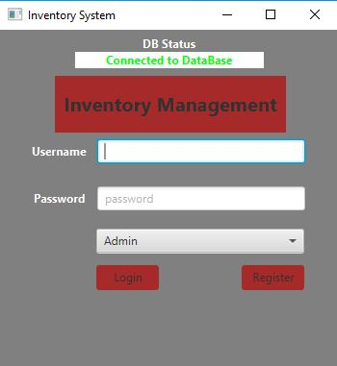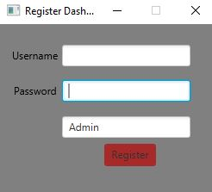

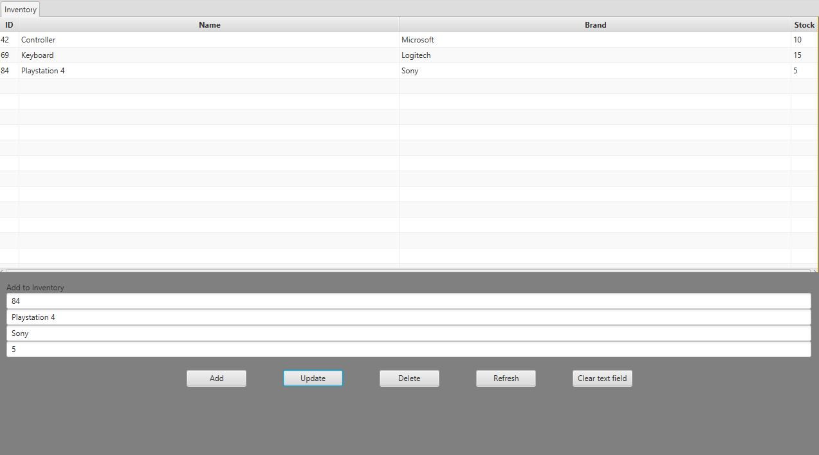

**References**

<https://www.youtube.com/watch?v=h1rYlMrvNyE>

<http://www.sqlitetutorial.net/>

<https://stackoverflow.com/questions/26424769/javafx8-how-to-create-listener-for-selection-of-row-in-tableview>